NAME: SHEEFA NAAZ

ROLL NO.: 2128085

SECTION: CSSE 2

DATE: 10-08-2023

- Write an R-script to initialize a vector and then find out minimum value and maximum value, also evaluate the sum of all the elements.

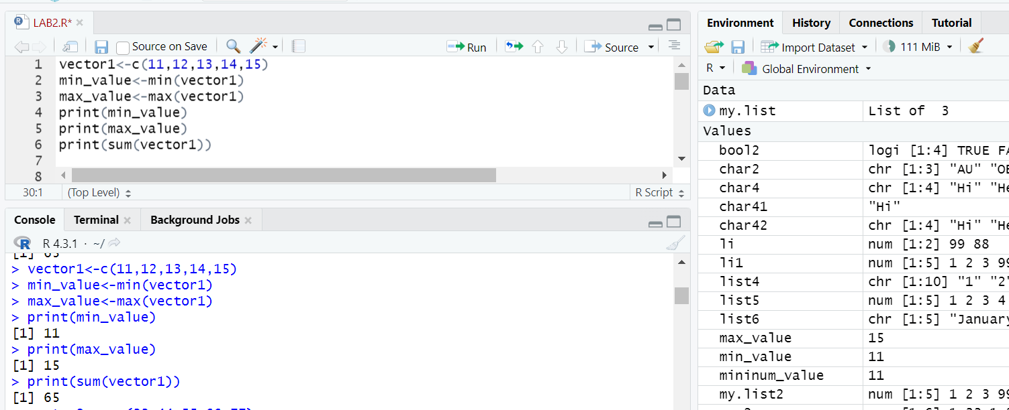

- Write an R-script to initialize a vector and then search a specific element from that vector.

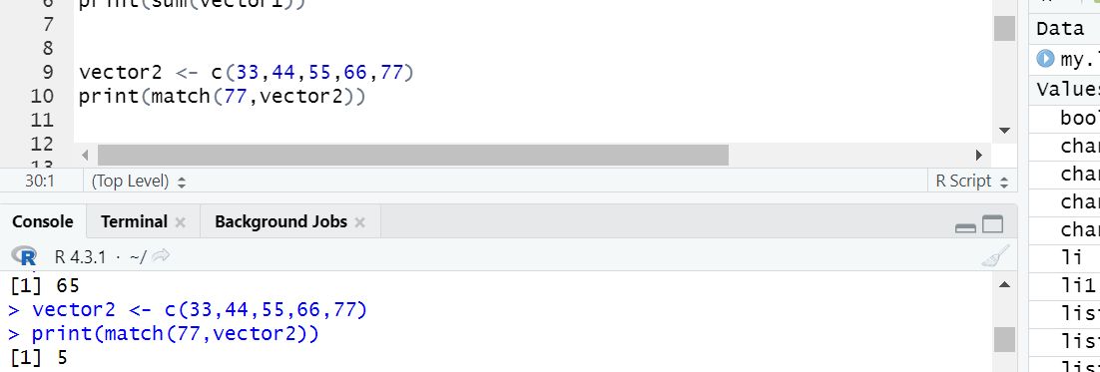

- Write an R-script to create a list with different types of data set. Now display each data set separately according to the data type.

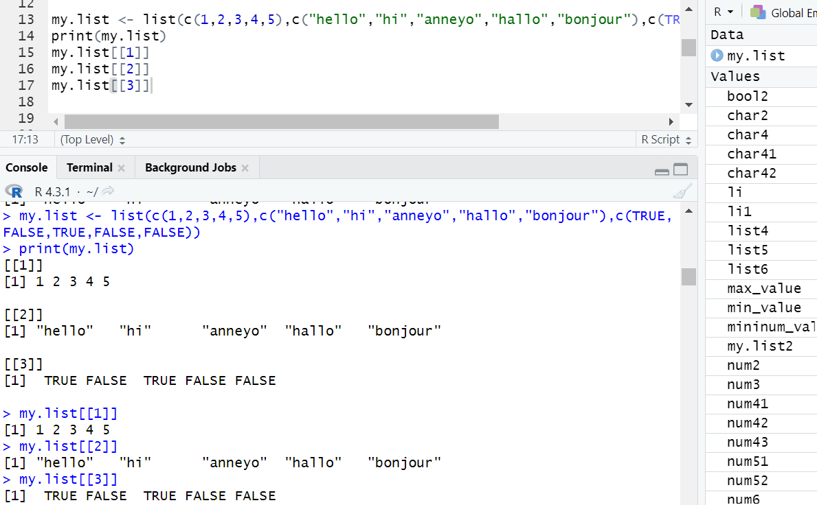

- Write an R-script to create a list having vector, and a list. Now display only the 2nd data set of the list.

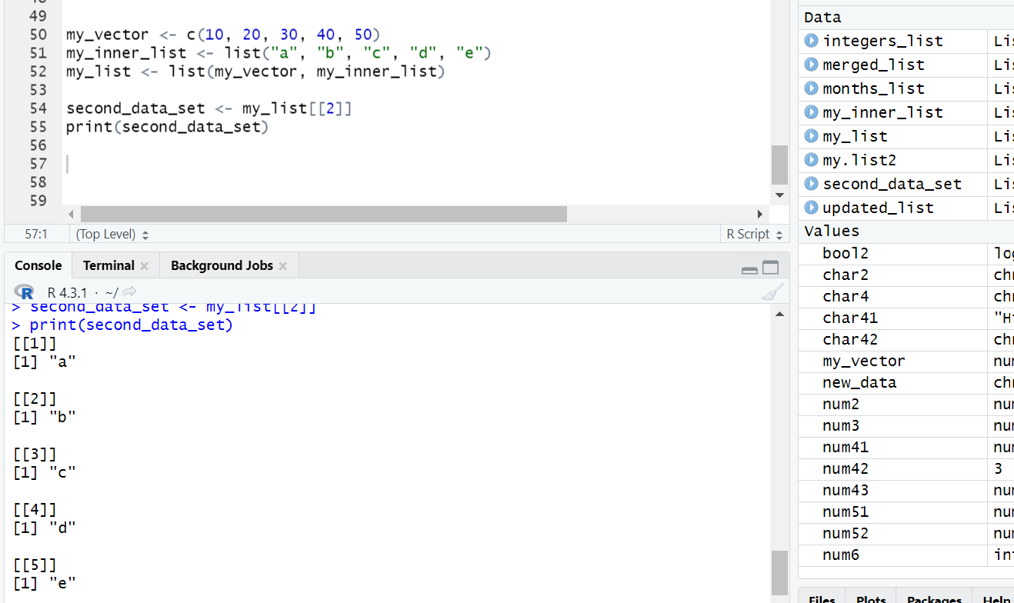

- Write an R-script to add a new data set to the previous list and also remove the 2nd data set from that list.

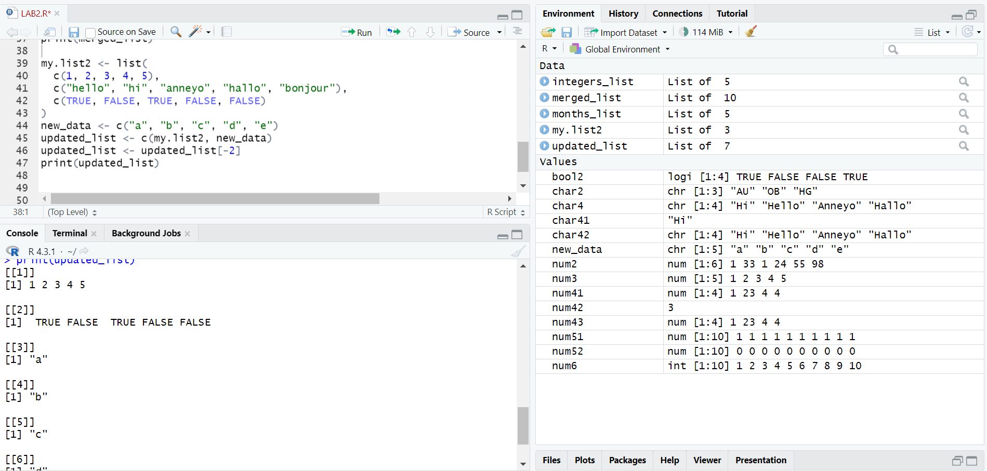

- Write an R-script to create two lists- one contains the integers from 1 to 5 and another contains the name of 5 months. Now merge two lists and display that.

